2018 CAPSTONE PROTOTYPE

Brian Colantonio

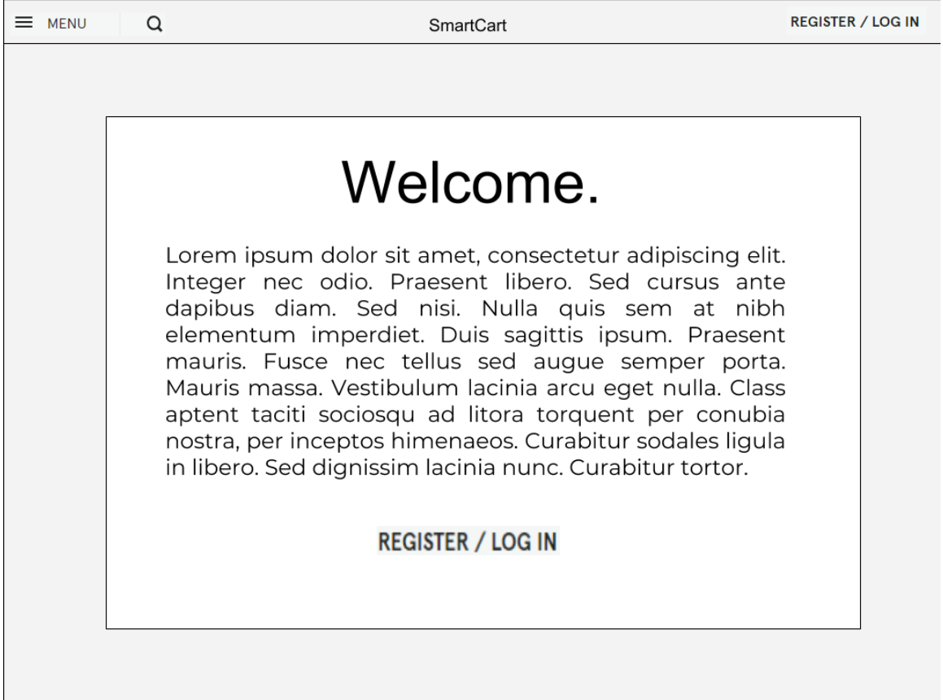

HOMESCREEN

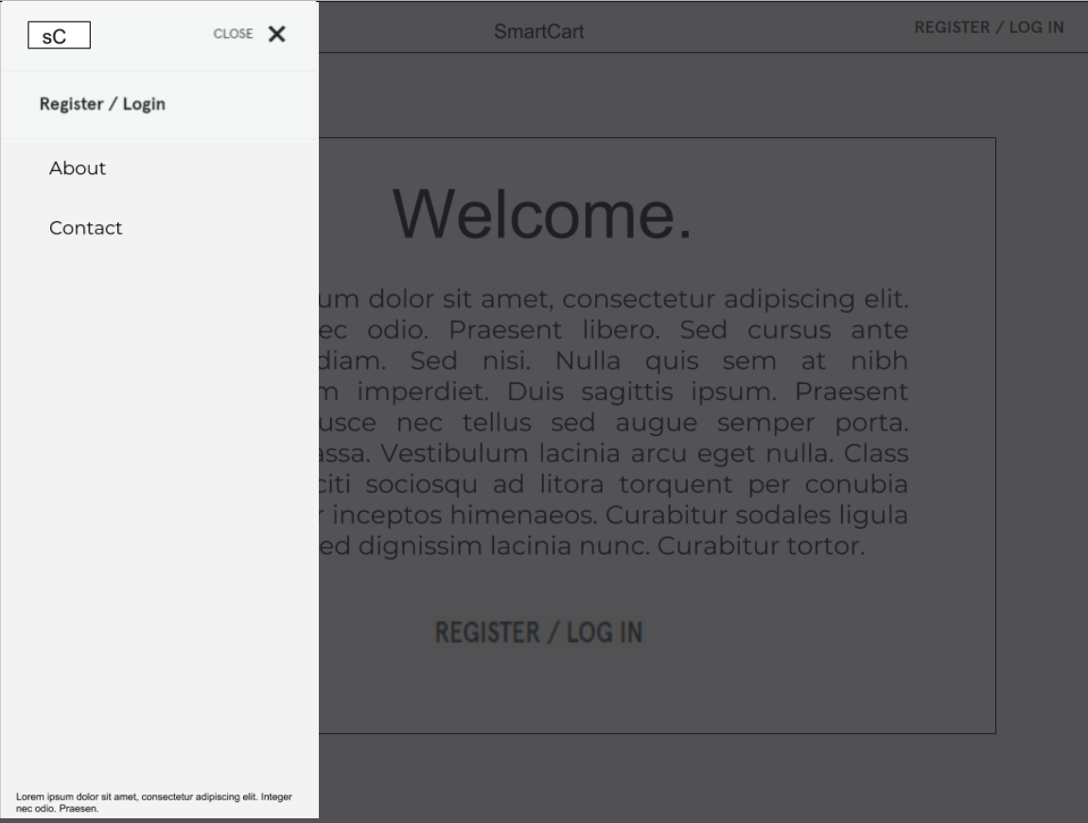

HOMESCREEN WITH SLIDEOUT MENU ENGAGED

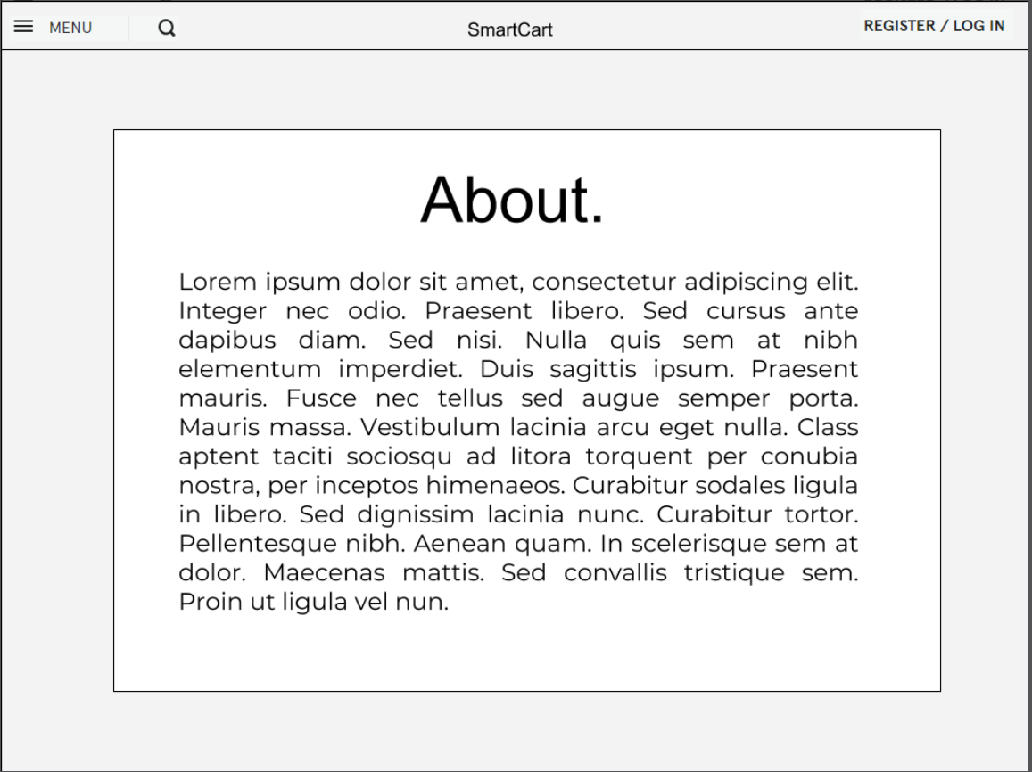

ABOUT PAGE

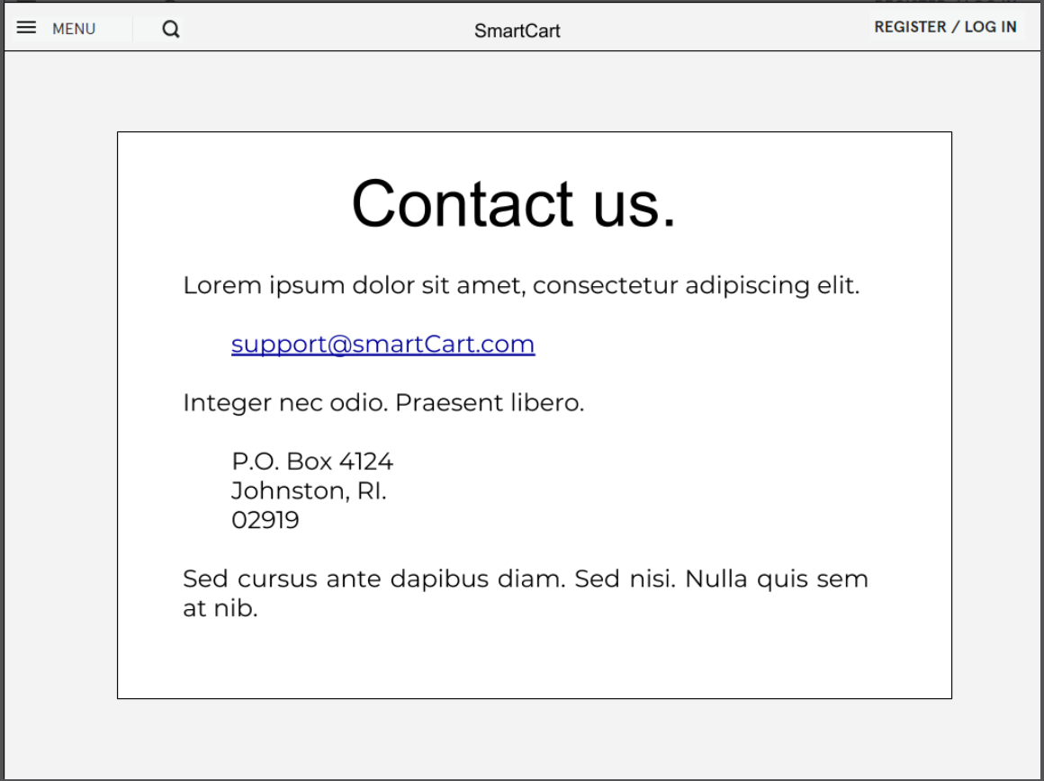

CONTACT PAGE

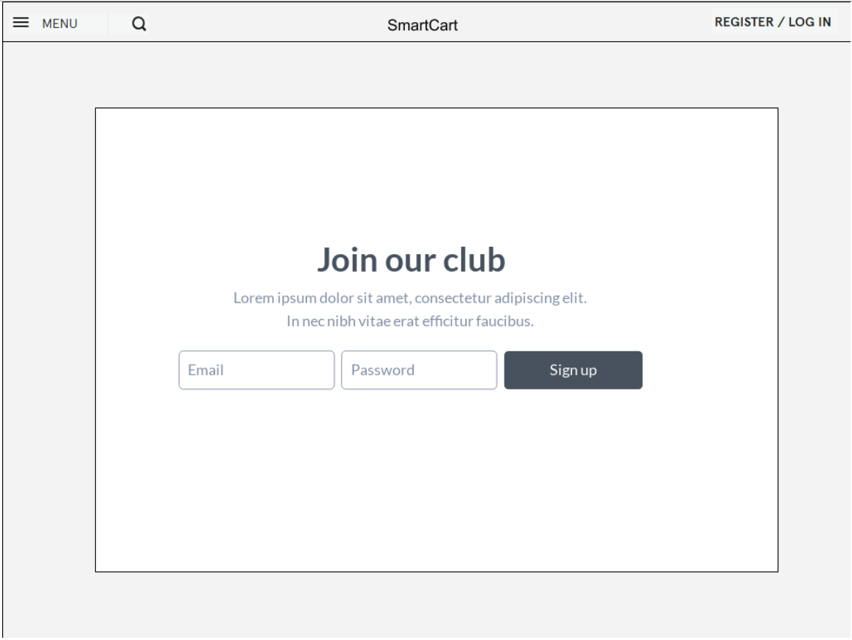

LOG IN PAGE

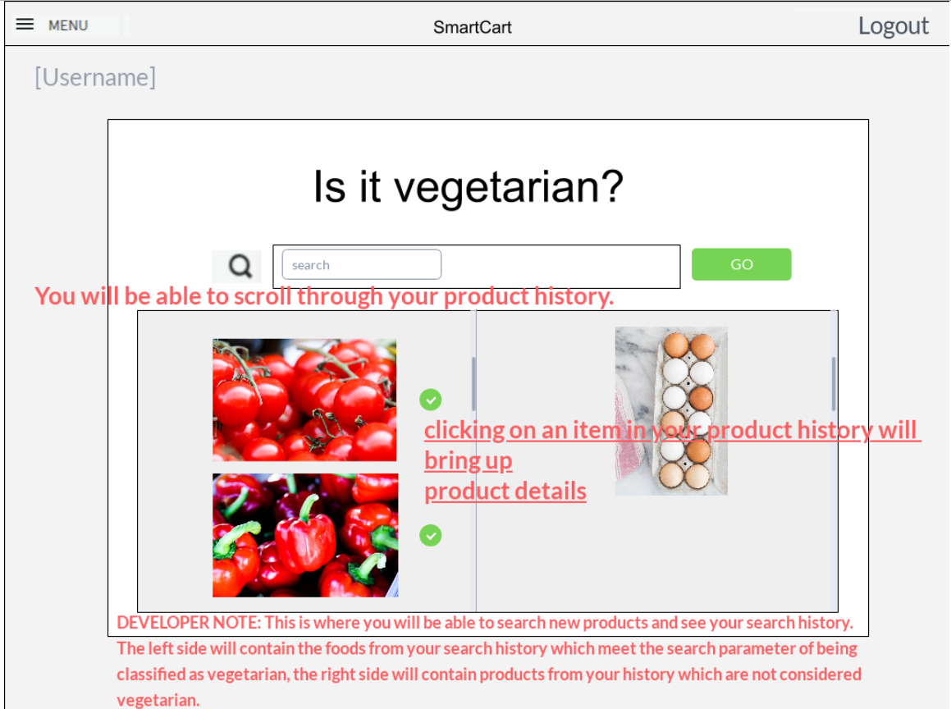

PROFILE HOME SCREEN

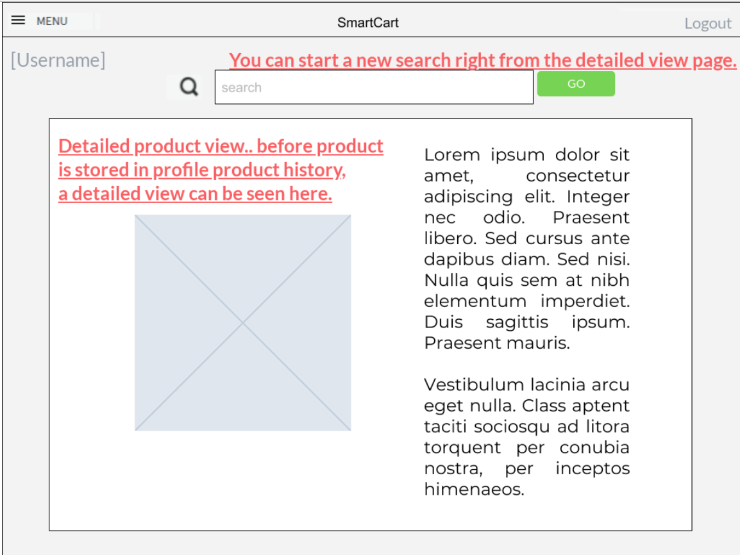

DETAILED PRODUCT VIEW